**DBMS LAB TASK-3**

**Name: Kommaraju Jahnavi**

**Reg No. : 121910306007**

**Section: B6**

Given tables,

1. SUPPLIER (SID, SNAME, SCITY)

2. PARTS (PID, PNAME, PCOLOR)

3. ORDERS (SID, PID, QUANTITY)

**SUPPLIER Table**

| **SID** | **SNAME** | **SCITY** |
| --- | --- | --- |
| S1 | Smith | London |
| S2 | Jones | Paris |
| S3 | Blake | Paris |
| S4 | Clark | London |
| S5 | Adams | USA |

**PARTS Table**

| **PID** | **PNAME** | **PCOLOR** |
| --- | --- | --- |
| P2 | BOLT | GREEN |
| P3 | SCREW | BLUE |
| P4 | SCREW | RED |
| P5 | CAM | BLUE |
| P6 | COG | RED |

**ORDERS Table**

| **SID** | **PID** | **QUANTITY** |
| --- | --- | --- |
| S1 | P1 | 300 |
| S1 | P2 | 200 |
| S1 | P3 | 400 |
| S1 | P4 | 200 |
| S1 | P5 | 100 |
| S1 | P6 | 100 |
| S2 | P1 | 300 |
| S2 | P2 | 400 |
| S3 | P2 | 200 |
| S4 | P2 | 200 |
| S4 | P4 | 300 |

1. **DRAW ER MODEL OF ABOVE SCHEMA**

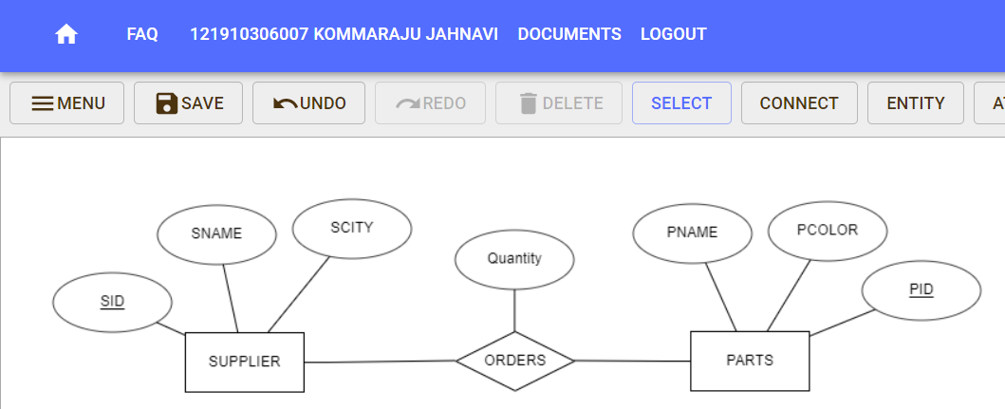

1. **Creating a Supplier database to set various constraints.**
2. **(a) Primary key (b)Foreign Key**
3. **(c) Unique (d) Null (e) Not null**

For SUPPLIER table:

CREATE TABLE SUPPLIER(SID VARCHAR(5) NOT NULL PRIMARY KEY, SNAME VARCHAR(10) NOT NULL, SCITY VARCHAR(10) NULL, UNIQUE(SNAME));

**Output:**

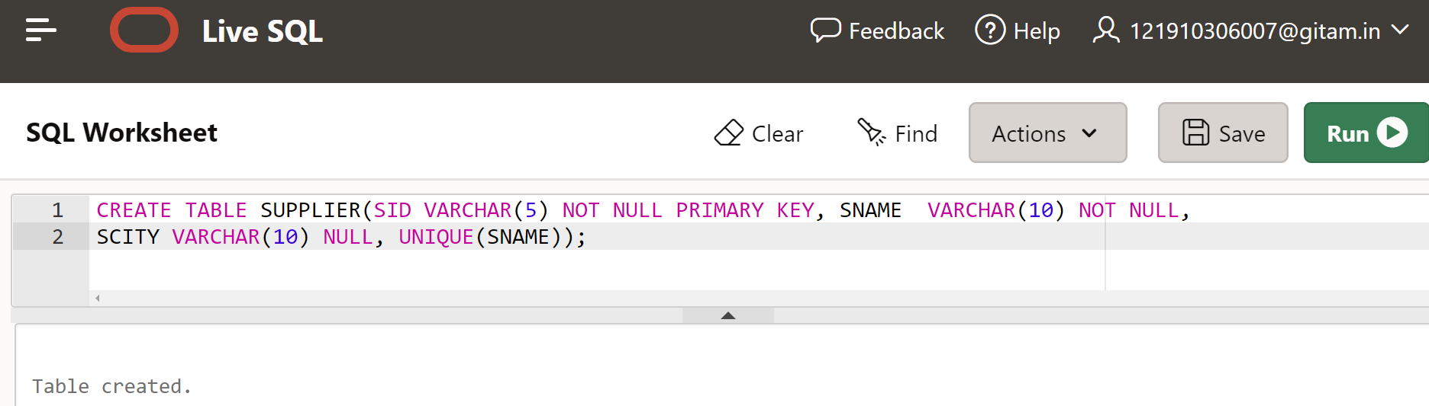

For PARTS table:

CREATE TABLE PARTS(PID VARCHAR(5) PRIMARY KEY, PNAME VARCHAR(10),PCOLOR VARCHAR(10));

**Output:**

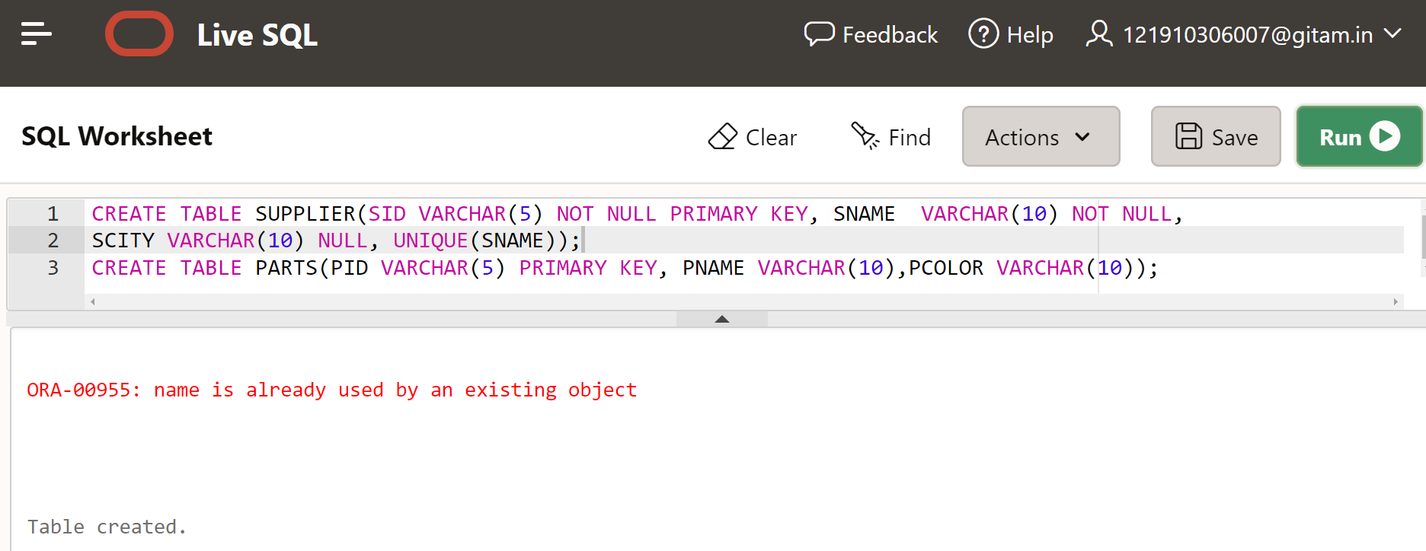

For ORDERS table:

CREATE TABLE ORDERS(SID VARCHAR(5),PID VARCHAR(5), QUANTITY INTEGER, PRIMARY KEY(SID,PID), FOREIGN KEY(SID) REFERENCES SUPPLIER, FOREIGN KEY(PID) REFERENCES PARTS);

**Output:**

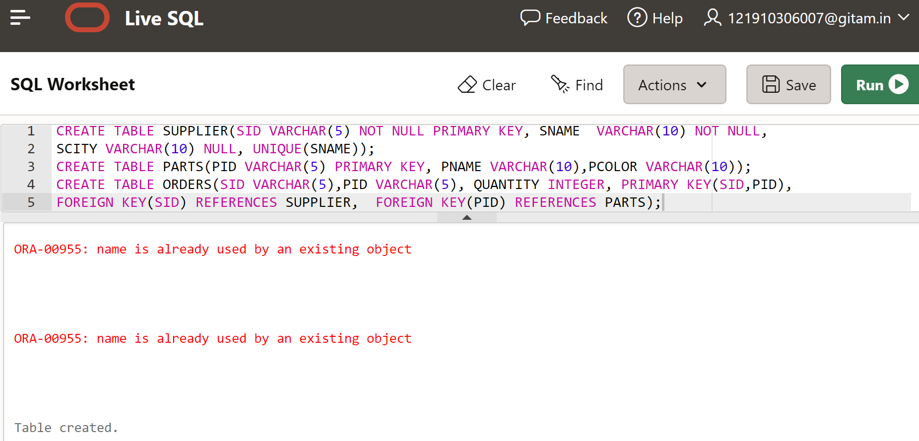

**3. INSERT THE VALUES INTO CORRESPONDING TABLES**

INSERT INTO SUPPLIER table:

INSERT INTO SUPPLIER(SID,SNAME,SCITY) VALUES('S1','Smith','London');

INSERT INTO SUPPLIER(SID,SNAME,SCITY) VALUES('S2','Jones','Paris');

INSERT INTO SUPPLIER(SID,SNAME,SCITY) VALUES('S3','Blake','Paris');

INSERT INTO SUPPLIER(SID,SNAME,SCITY) VALUES('S4','Clark','London');

INSERT INTO SUPPLIER(SID,SNAME,SCITY) VALUES('S5','Adams','USA');

**Output:**

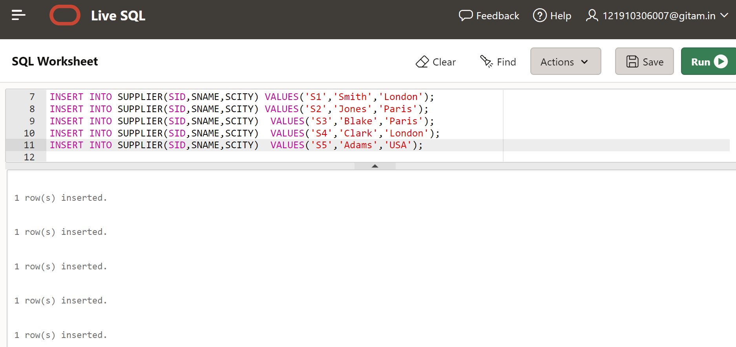

INSERT INTO PARTS table:

INSERT INTO PARTS(PID,PNAME,PCOLOR) VALUES('P2','Bolt','Green');

INSERT INTO PARTS(PID,PNAME,PCOLOR) VALUES('P3','Screw','Blue');

INSERT INTO PARTS(PID,PNAME,PCOLOR) VALUES('P4','Screw','Red');

INSERT INTO PARTS(PID,PNAME,PCOLOR) VALUES('P5','Cam','Blue');

INSERT INTO PARTS(PID,PNAME,PCOLOR) VALUES('P6','Cog','Red');

**Output:**

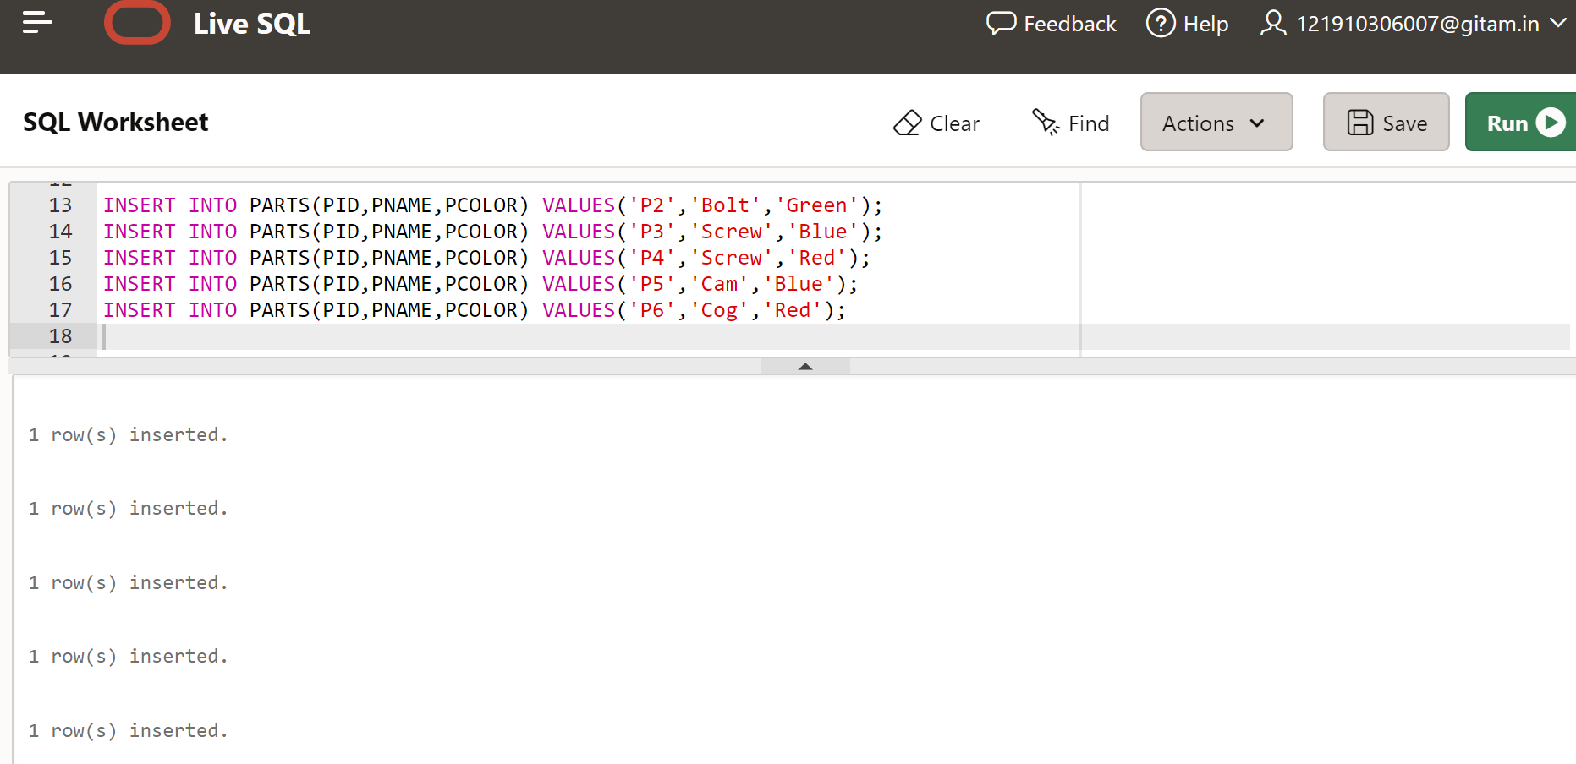

INSERT INTO ORDERS table:

INSERT INTO ORDERS(SID,PID,QUANTITY) VALUES('S1','P1','300');

INSERT INTO ORDERS(SID,PID,QUANTITY) VALUES('S1','P2','200');

INSERT INTO ORDERS(SID,PID,QUANTITY) VALUES('S1','P3','400');

INSERT INTO ORDERS(SID,PID,QUANTITY) VALUES('S1','P4','200');

INSERT INTO ORDERS(SID,PID,QUANTITY) VALUES('S1','P5','100');

INSERT INTO ORDERS(SID,PID,QUANTITY) VALUES('S1','P6','100');

INSERT INTO ORDERS(SID,PID,QUANTITY) VALUES('S2','P1','300');

INSERT INTO ORDERS(SID,PID,QUANTITY) VALUES('S2','P2','400');

INSERT INTO ORDERS(SID,PID,QUANTITY) VALUES('S3','P2','200');

INSERT INTO ORDERS(SID,PID,QUANTITY) VALUES('S4','P2','200');

INSERT INTO ORDERS(SID,PID,QUANTITY) VALUES('S4','P4','300');

**Output:**

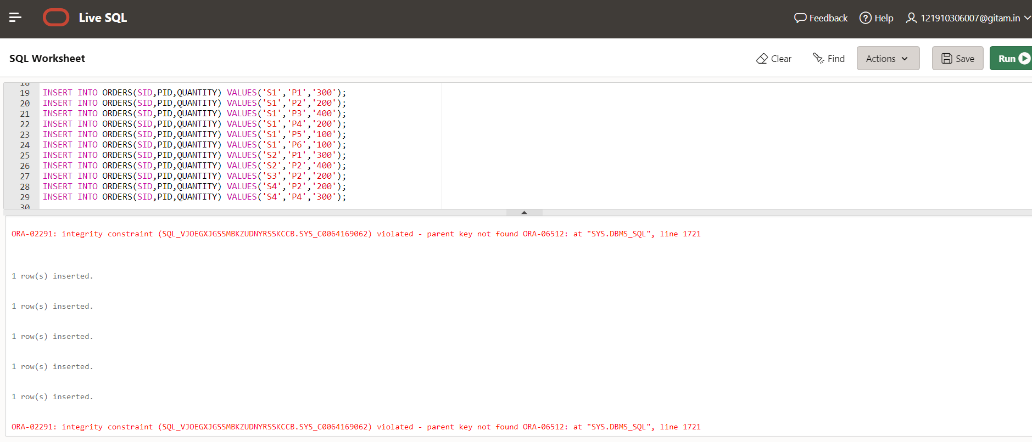

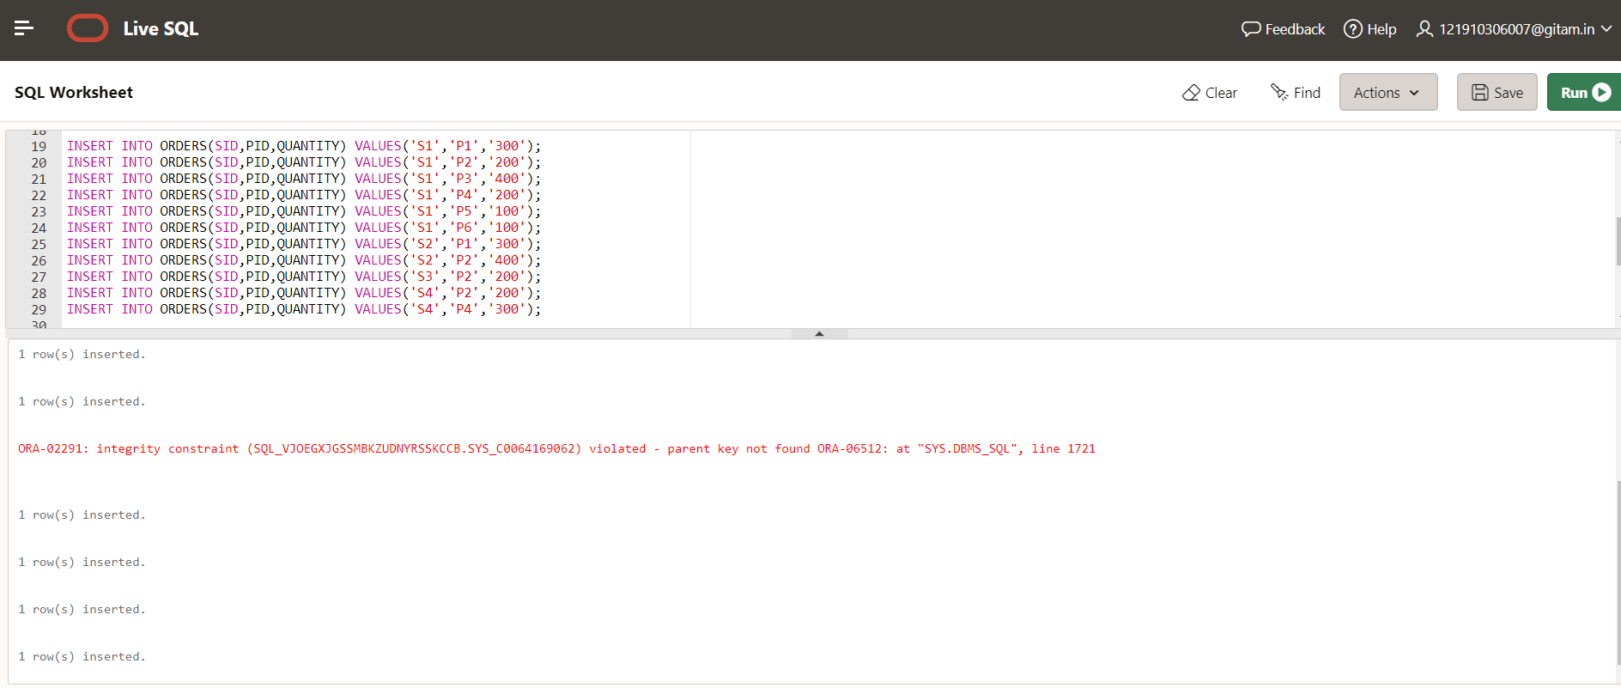

In the above, while inserting ‘P1’ we get integrity constraint violated -parent key not found error because PID ‘P1’ is not present in PARTS table

**4. Display the Tables**

For SUPPLIER table:

SELECT * FROM SUPPLIER;

**Output:**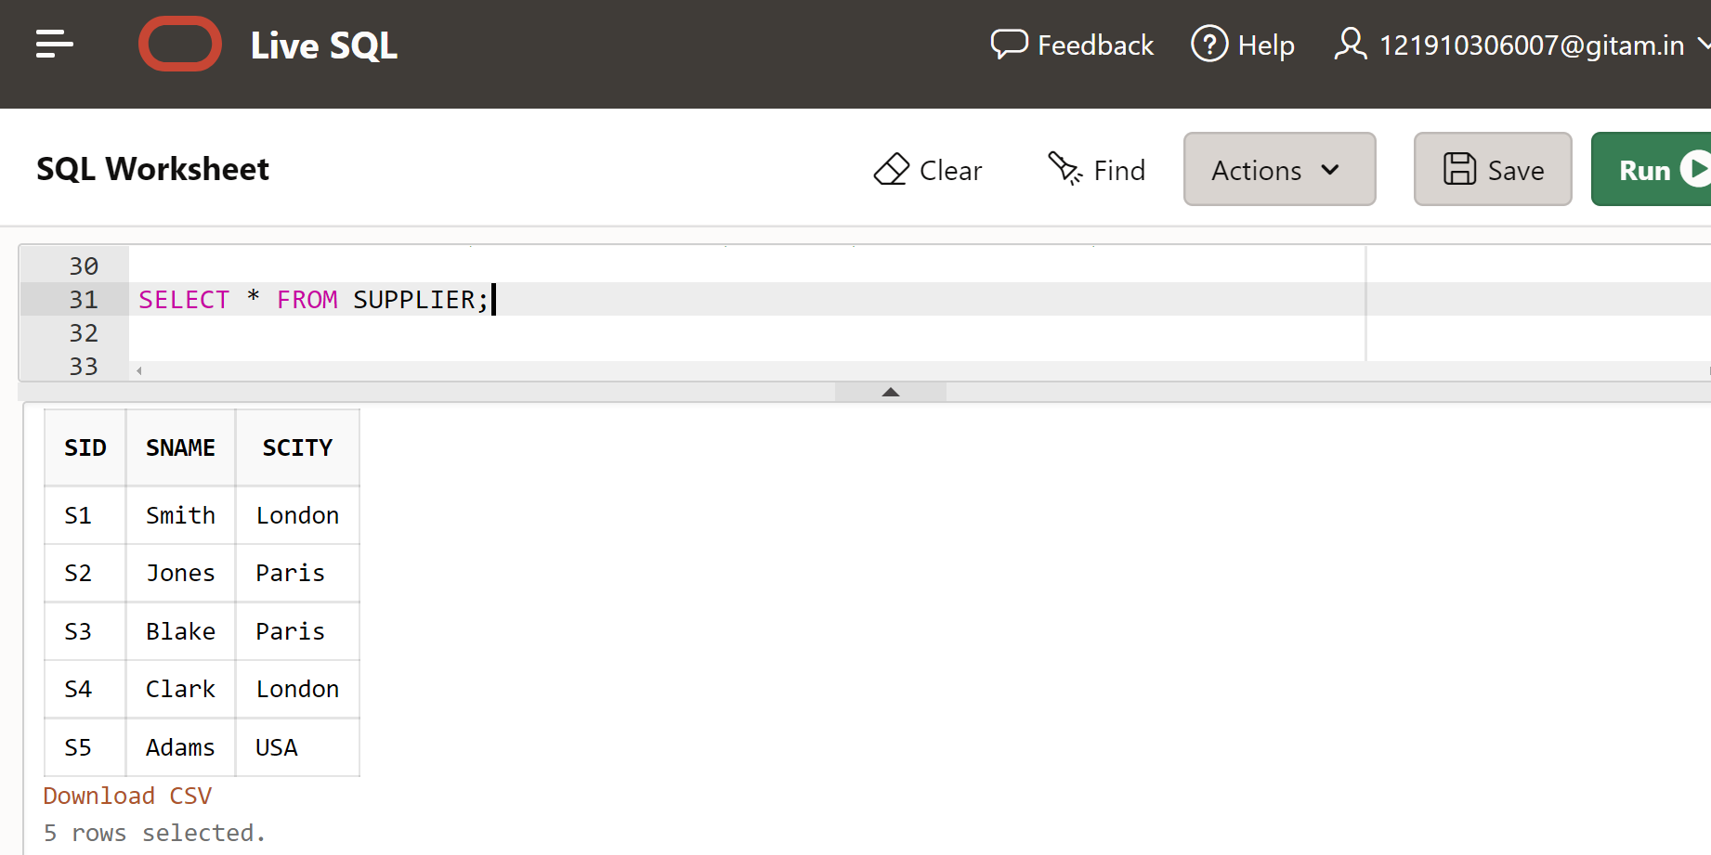

For PARTS table:

SELECT * FROM PARTS;

**Output:**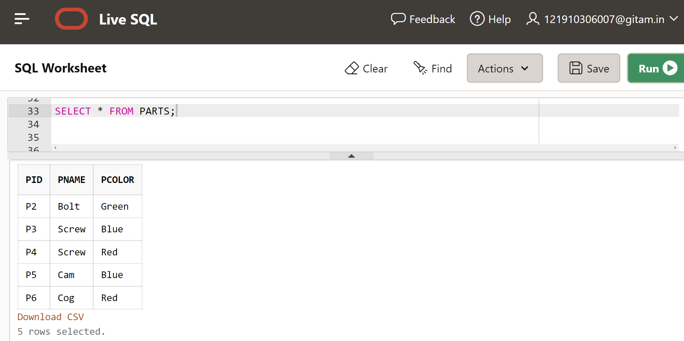

For ORDERS table:

SELECT * FROM ORDERS;

**Output:**

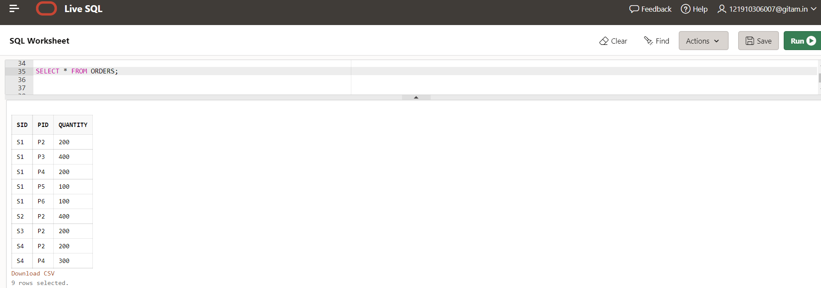

**5. Update the Sname as Adams at SID S3.Write the Result.**

UPDATE SUPPLIER SET SNAME='Adams'

WHERE SID='S3';

SELECT * FROM SUPPLIER;

**Output:**

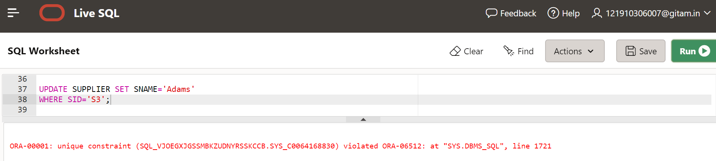

In the above, we have an unique constraint error because while creating SUPPLIER table, SNAME is set to have unique value.

**6. Find the SNames and SID who have ordered in P6 Parts**

SELECT S.SID, S.SNAME

FROM SUPPLIER S, PARTS P, ORDERS O

WHERE S.SID=O.SID AND P.PID=O.PID AND O.PID='P6';

**Output:**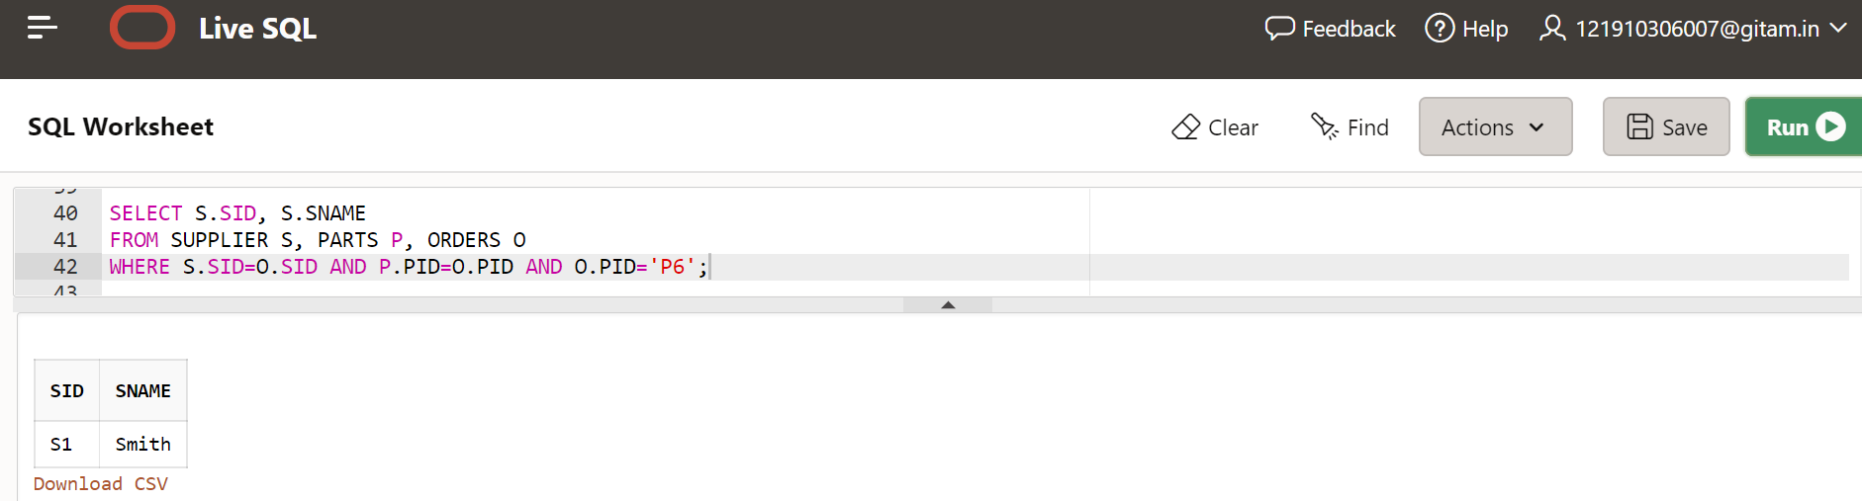

**7. Try to Modify the Data type of PNAME Column.**

ALTER TABLE PARTS MODIFY PNAME CHAR(20);

DESC PARTS;

**Output:**

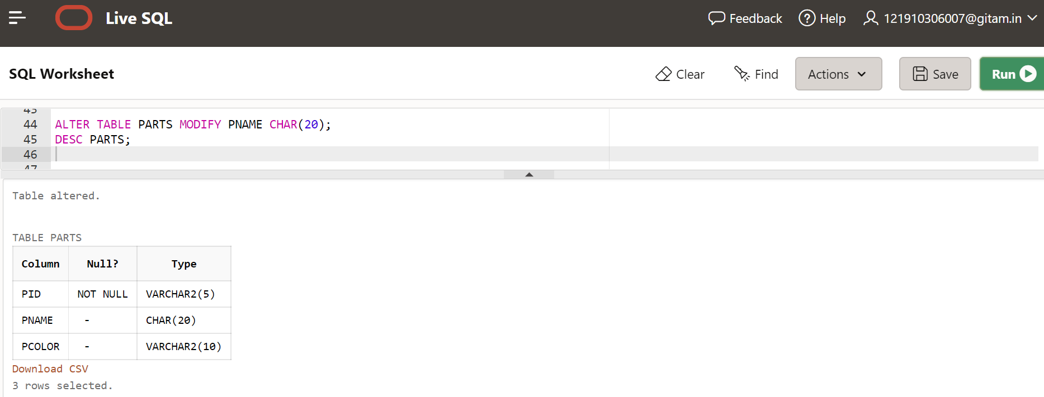

**8. Find the pname whose part parts color = blue**

SELECT PNAME

FROM PARTS

WHERE PCOLOR='Blue';

**Output:**

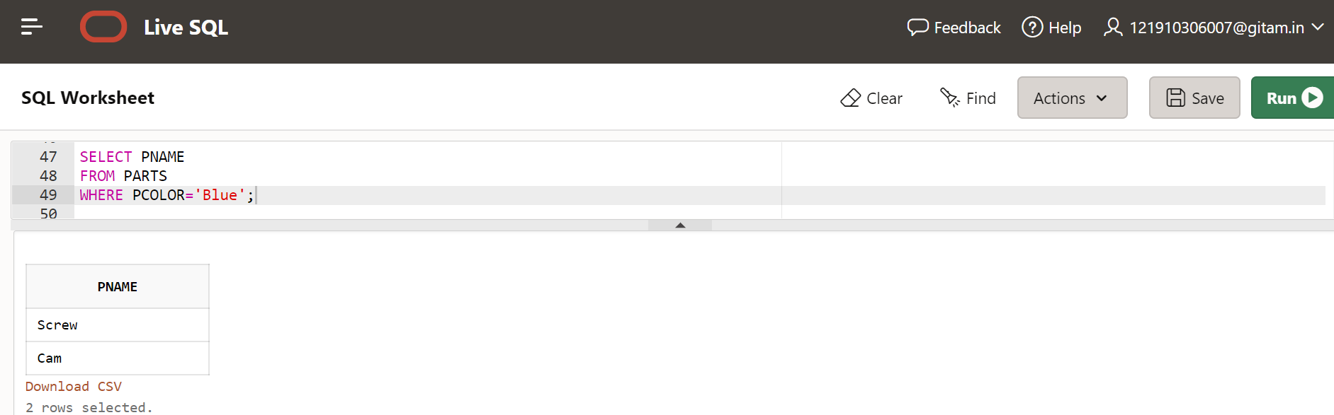

**9. Find the sid who have order the P2 Parts**

SELECT O.SID

FROM ORDERS O, PARTS P

WHERE O.PID= P.PID AND O.PID='P2';

**Output:**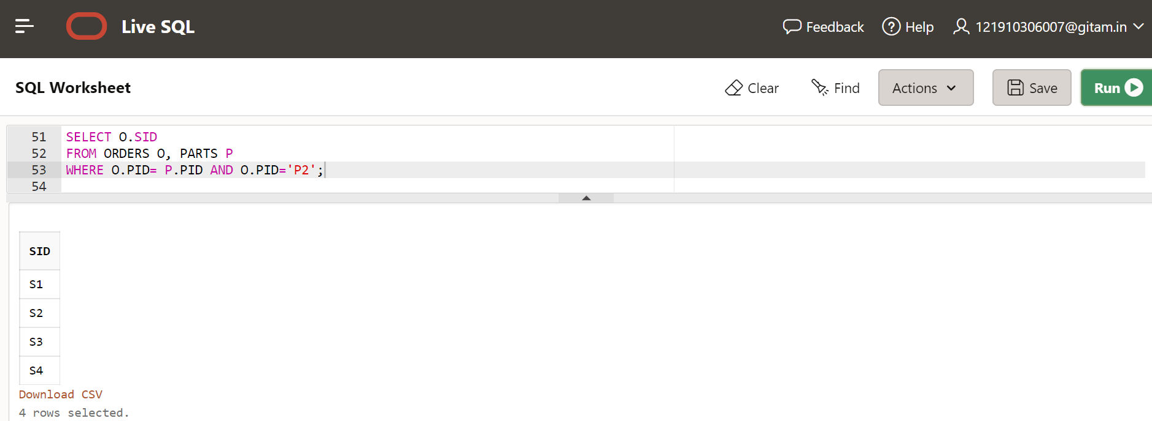

**10. Find the Names who have ordered parts**

SELECT S.SNAME

FROM ORDERS O, SUPPLIER S

WHERE O.PID=O.PID AND O.SID=S.SID;

**Output:**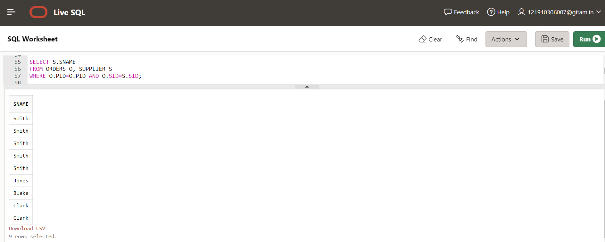

**11. Find all sids of suppliers who belongs to London.**

SELECT SID

FROM SUPPLIER

WHERE SCITY='London';

**Output:**

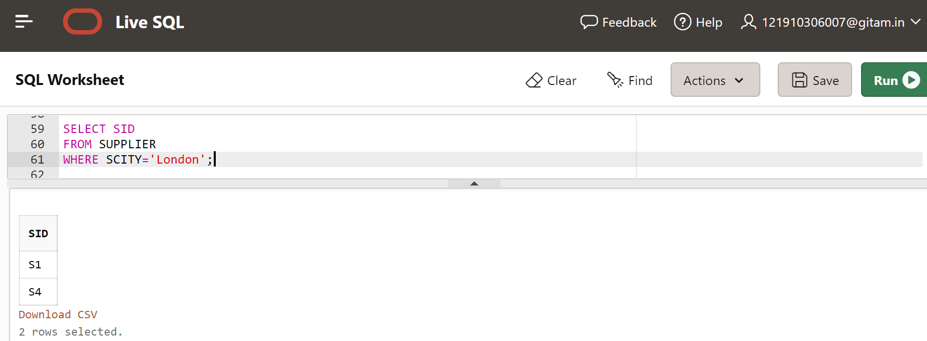

**12. Find the Sids and Names who have ordered parts id P4.**

SELECT S.SID, S.SNAME

FROM SUPPLIER S, PARTS P, ORDERS O

WHERE S.SID=O.SID AND P.PID=O.PID AND O.PID='P4';

**Output:**

